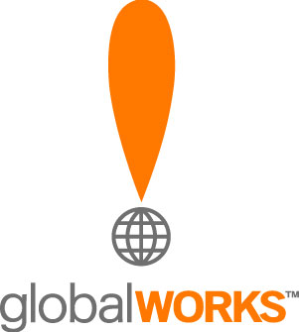
Hughes Enterprise Site
Headlines for Slideshow Navigation
5/26/09

Training and learning

Lesson Plans

You’ve got a large, scattered workforce and constantly evolving technology.
Now you need to make sure everyone gets on the same page.

Jumpstart the learning process.

[Box:] See how Hughes can help train and educate your workforce.

30% cost savings

Big Savings for Big Business

Need to reduce overhead? How about starting with your network?
Save up to 30% with managed network services provided by Hughes.

[Box:] Reduce your costs by up to 30% with Hughes.

Utilities

A Smarter Grid

Today’s utility systems need to be secure, efficient and environmentally sound.
Without a reliable remote monitoring solution, you could be in for a shock.

Click here for an intelligent approach to support grids.

[Box:] Trust Hughes to keep your grid secure and compliant.

Digital Signage

Create the Point of Impact

Captive audience advertising is a great way to influence buying decisions at the point of purchase.

Make sure your customers get the message.

[Box:] Send the right message to the right audience with Hughes Digital Signage.

Managed Network Services

All the performance you need. All from one place.

Whatever your business or technological objectives, our vast array of Managed Network Services will keep you connected, up-to-speed, and in control.

Make your network stand out from the crowd.

[Box:] Hughes has a fully managed turnkey solution that’s right for you.

Access Continuity

There’s no time for downtime.

Blackouts. Severe weather. Construction accidents along your broadband infrastructure.
All can mean disaster for your network. Unless you’re the guy with a diverse-path backup solution.

Take out an insurance policy on your network.

[Box:] Keep mission-critical applications running with Access Continuity from Hughes.

